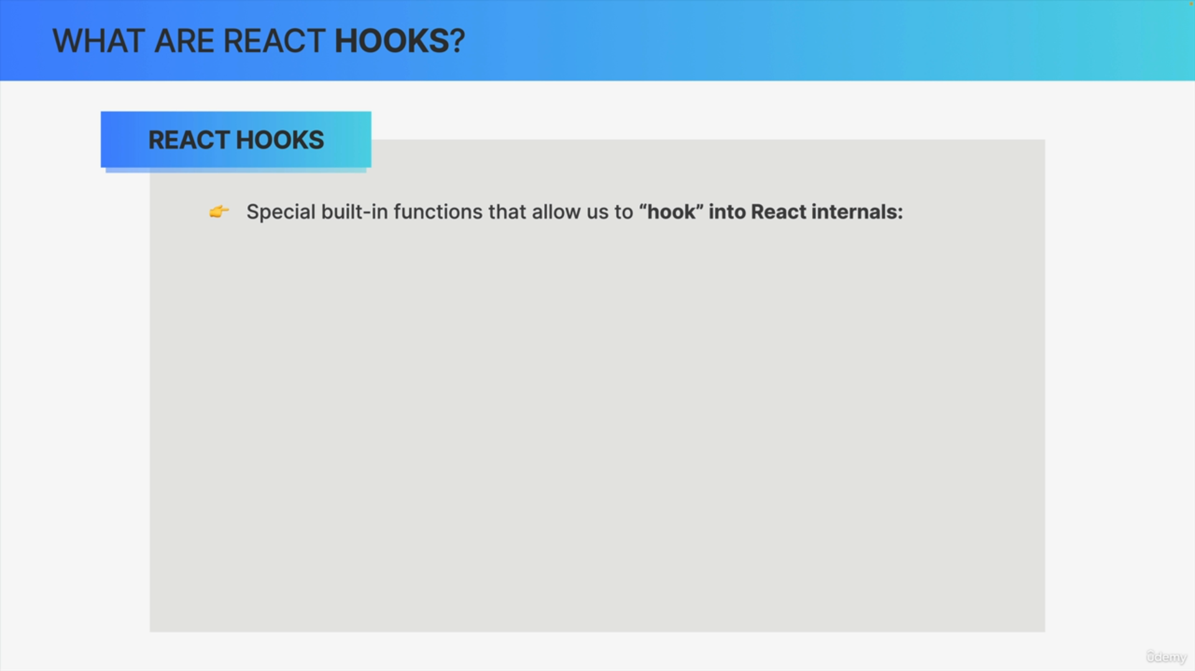

React hooks are essentially special functions that are built into React and which allow us to basically hook into some of React's internal mechanisms.

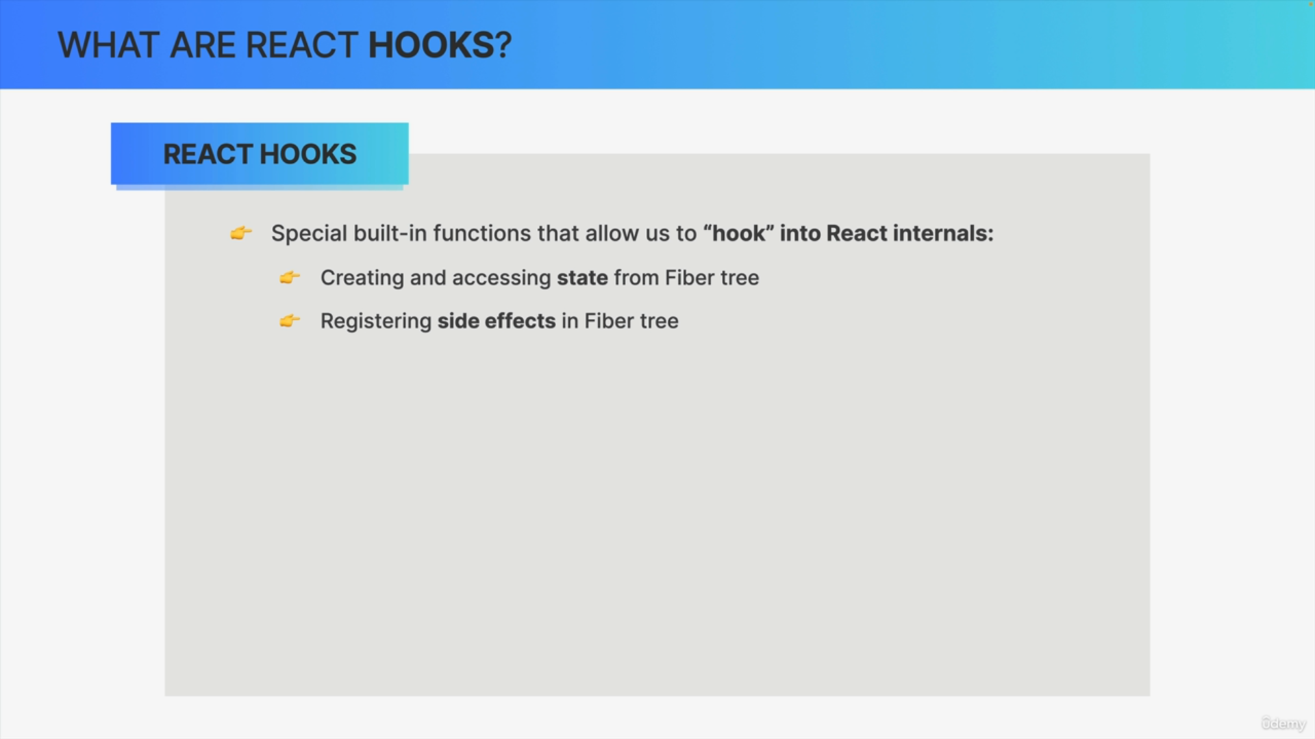

Hooks are basically APIs that expose some internal React functionality, such as creating and accessing state from the fiber tree or registering side effects in the fiber tree.

The fiber tree is somewhere deep inside React and usually not accessible to us at all but using the useState or the useEffect hook, we can essentially hook into that internal mechanism.

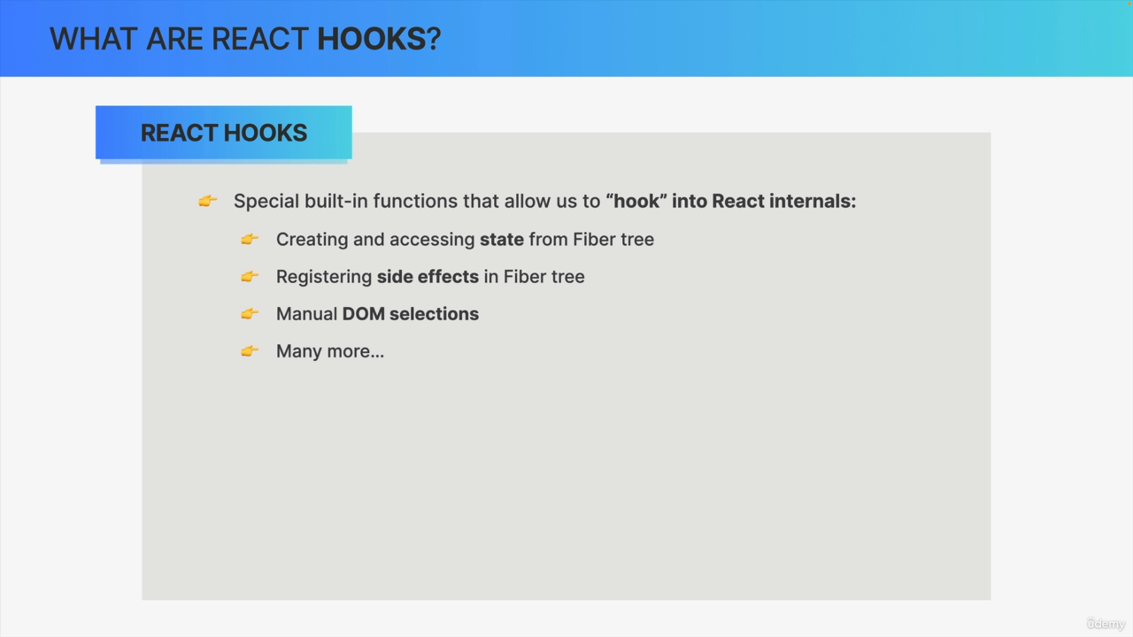

Hooks also allow us to manually select in-store DOM notes access context and many other things.

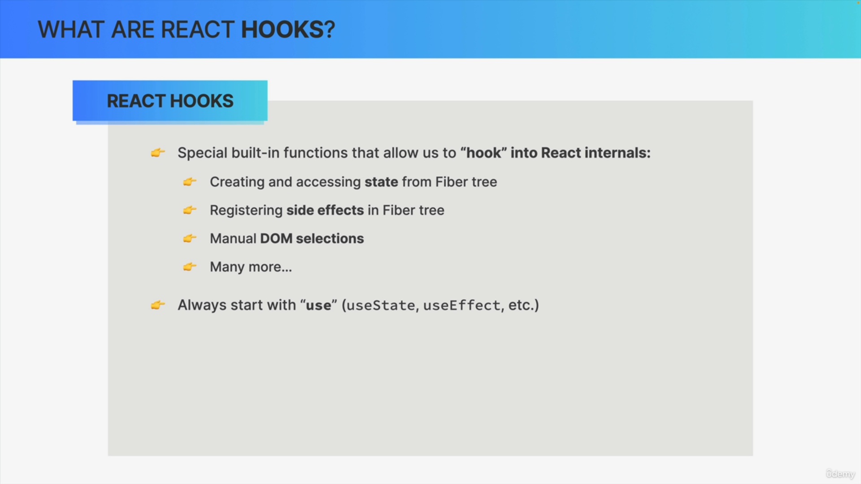

All Hooks start with the word "use," in order to make it easy for us and for React to distinguish hooks from other regular functions.

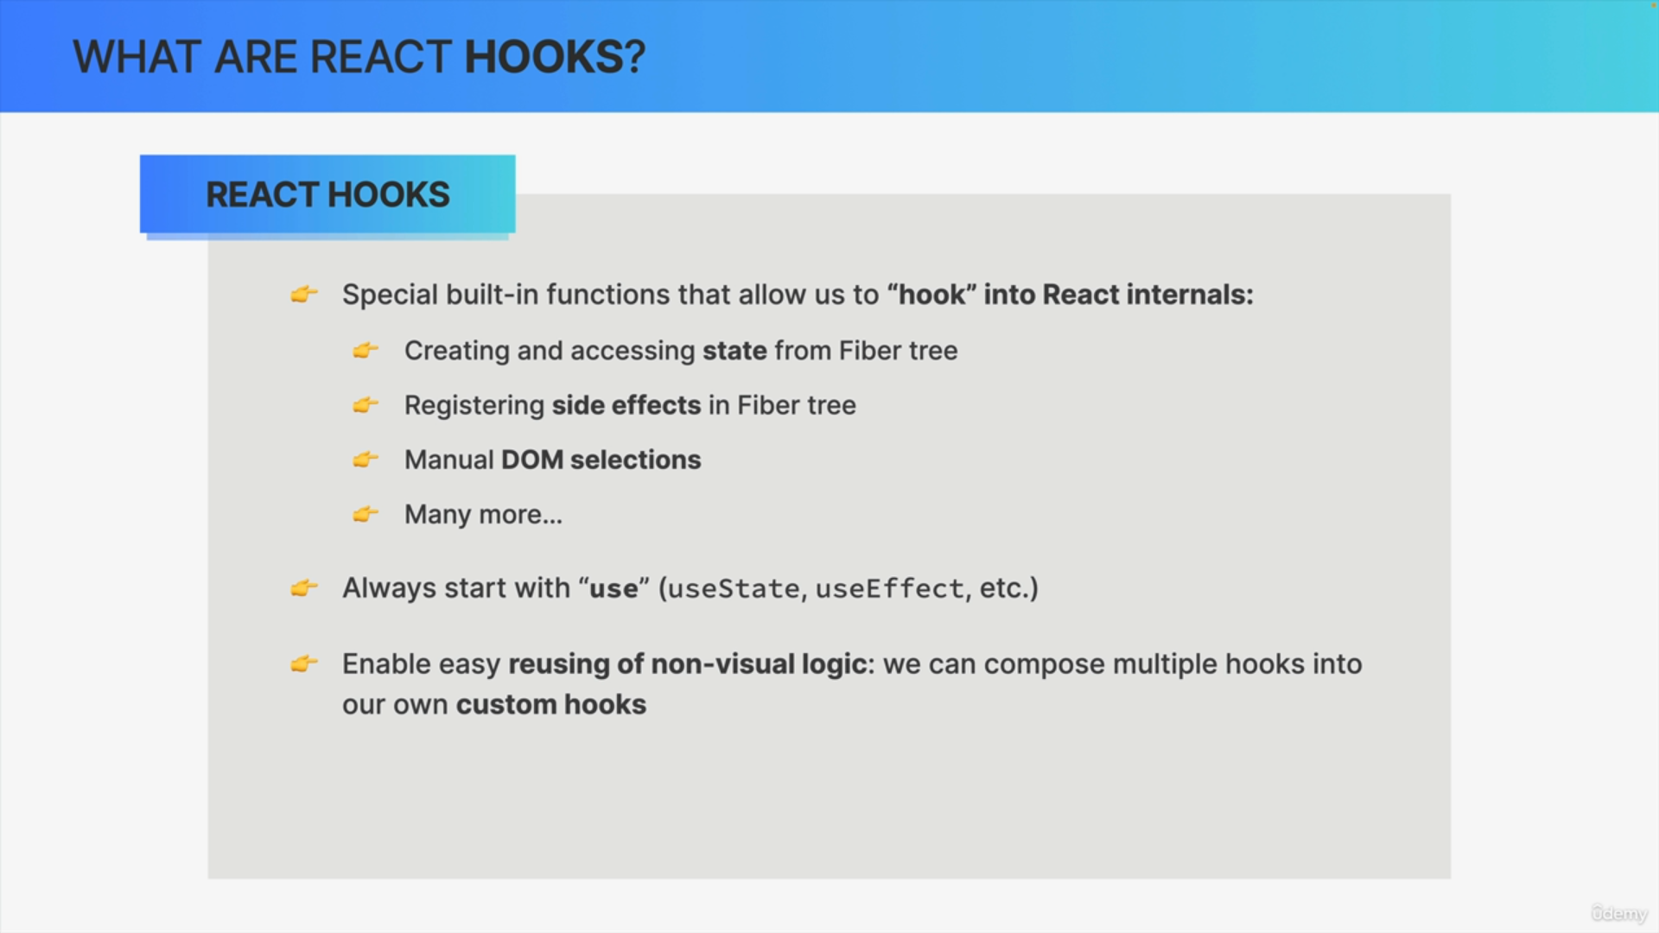

We can even create our own so-called custom hooks, which will also start with the word "use." This is actually one of the greatest things about hooks in general, because custom hooks give us developers an easy way of reusing non-visual logic. So, logic that is not about the UI.

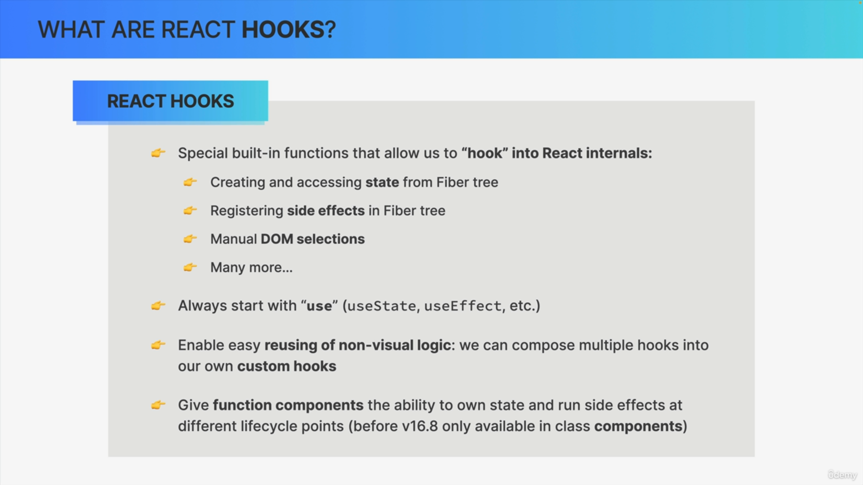

There was a time when we had to use components based on JavaScript classes if we wanted to give components state and access to the component life cycle.

However, this came with a few problems,which led the React team to introduce hooks.

With hooks, our components based on functions can have their own state and also run side effects. This was a huge step forward for React and made it even more popular than it already was.

